UPPER HARBOUR REGIONAL MARINE CENTRE, CATALINA BAY, HOBSONVILLE POINT
Planning is underway for a community Marine Centre to be established at Hobsonville Point serving the Upper Harbour region.
The multi-purpose marine Centre will serve the rapidly growing North West sector of the city and will be the only one of its kind north of the Harbour Bridge.
Sited over the water, the two story facility will comprise an all-purpose community “clubhouse” and equipment storage for a mix of water sports.
A wharf and pontoon will provide all tide access for marine sports and recreation activities and the public.
Foundation sports based at the Centre will include sailing, rowing and sea cadets (currently based on the Point), with others to be added in time.
The Centre will also provide youth training and education programmes, promoting health and wellbeing and fostering an appreciation and understanding of the marine environment.
Rowing NZ’s Auckland Regional Performance Centre will also be based at the Centre.
The Marine Centre and its facilities will be available for use by the wider community, user groups and schools.
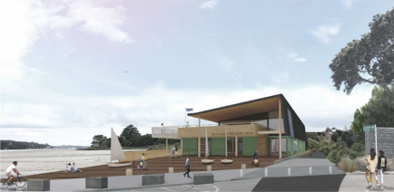Launch Rd
FACILITY FEATURES
The 900m2 Centre’s design will be of low impact visually and respect the important historical, environmental and natural features of the site.
A wharf will link the Marine Centre with the water, providing access at all tide levels for users and members of the public.
The facility will have 3 core functional areas:
1. Upper Level: Community Clubhouse and deck
2. Ground floor : 900m2 equipment storage for water sports and recreation
• Secure hard stand areas for the storage of skiffs, sailing dinghies, dinghies, light marine (e.g. kayak, SUP etc.) and safety craft
• Public ablutions
3. Public launching facilities
• 65m x 4m wide wharf, ramps and pontoons for launching of light water craft – skiffs, dinghies, kayaks, waka ama etc.
• Providing deep water access at low and high tides
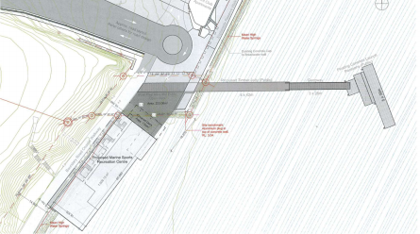
COMMUNITY BENEFIT
• The Centre will act as a community hub and family friendly environment, in a stunning location over the water adjacent to Bomb Point and Catalina Bay
• Membership of the Centre will be available to the general public, providing facility access and private equipment storage options (e.g. kayak, SUP, sailing dinghies etc.)
• The public will have access to the wharf and launching pontoon for water sports at all times, free of charge
• The Centre’s facilities will be available for hire by community user groups and for functions etc. and as a meeting place for recreation and exercise groups such as walking, jogging groups etc. • The Centre will provide sport and recreation programmes in sailing and rowing for all ages and for local schools
• Foundation Youth Programmes in sailing, rowing and sea cadets (others to be added), promoting health and wellbeing and fostering an appreciation and understanding of the marine environment • The Marine Centre will also host Rowing NZ’s Auckland Regional Performance Rowing Centre, to train and develop regional rowing talent.
• Ablutions will be available to the public
• The Centre will be operated by a not for profit charitable trust.
Community
Centre and
Ownership
Legacy FacilityMarine
Membership
and Clubrooms
Marine
Foundation
Stewardship and
Youth and
Centre
Education
Schools
Programmes
Deep Water
Access. Wharf, Pontoon for Launching
Water Sports
and Recreation
for all ages
Equipment
Equipment
Storage for
Water Sports

About the Hobsonville Point Sports and Recreation Centre Trust
• The Hobsonville Point Marine Sports Recreation Centre Trust (HPMSRT) has been established to develop and operate the Marine Sports and Recreation facility at Hobsonville Point and to conduct marine oriented sports and recreation programmes.
• The Trust’s core stakeholders initially include:
o Hobsonville Yacht Club. Currently based at Hobsonville Point.
o Westlake Boys High School Rowing Society (affiliate of North Shore Rowing Club). Currently based at Hobsonville Point
o Hobsonville Point Residents Society
o Kainga Ora (formerly Hobsonville Land Company)
Our Vision
• A vibrant community centre of marine sports and recreation for the Upper Harbour region
Our Mission
• To establish a marine sports and recreation centre serving the communities of Hobsonville and the Upper Harbour

